**OOAD LAB – 4**

Name : Sanmat Sanjayakumar Payagoudar

SRN : PES1UG20CS385

Section : G

**1.**

**Code :**

public class 3 {

}

public class sparrow {

    sparrow(){

        System.out.println("A sparrow is flying");

    }

    sparrow(String name){

        System.out.println(name + " is flying");

    }

    sparrow(String name,int height){

        System.out.println(name +" is flying at height "+height + " metres.");

    }

    sparrow(String name,int height,int speed){

        System.out.println(name + " is flying at height " +height+" metres and at speed "+speed +" metres per second.");

    }

    public static void main(String [] args){

        sparrow b1 = new sparrow();

        sparrow b2 = new sparrow("sanmat");

        sparrow b3 = new sparrow("sanmat",500);

        sparrow b4 = new sparrow("sanmat",500,100);

    }

}

**Out put :**

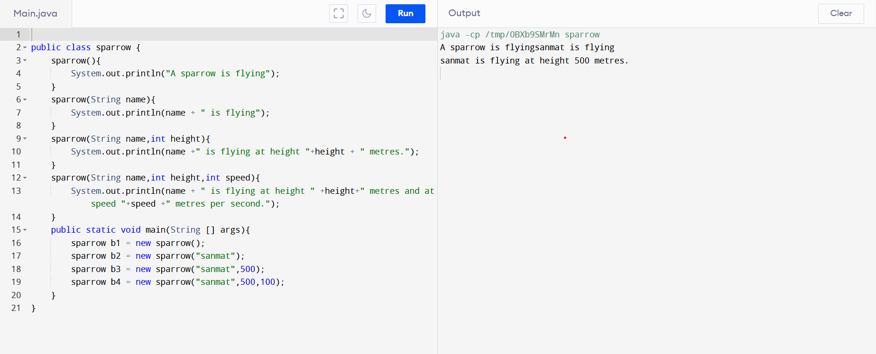

**2.**

**Code :**

public class bugati {

    private String make;

    private String model;

    private int year;

    private double mileage;

    bugati(String make, String model, int year, double mileage) {

       this.make = make;

       this.model = model;

       this.year = year;

       this.mileage = mileage;

    }

    public String getMake(){

         return this.make;

    }

    public String getModel(){

         return this.model;

    }

    public int getYear(){

         return this.year;

    }

     public double getMileage(){

           return this.mileage;

     }

     public void setMake(String make){

         this.make=make;

     }

     public void setModel(String model){

         this.model=model;

     }

     public void setYear(int year){

         this.year=year;

     }

     public void setMileage(double mileage){

         this.mileage=mileage;

     }

     public void display(){

         System.out.println("Make:"+this.make);

         System.out.println("Model:"+this.model);

         System.out.println("Year:"+this.year);

         System.out.println("Mileage:"+this.mileage);

     }

 public double cost(double distance,double costperlitre){

     return ((distance/this.getMileage()) * costperlitre);

 }

 public double cost(double costperlitre){

     return ((1/this.getMileage())*costperlitre);

 }

  public static void main(String args[]){

      bugati c1=new bugati("bugati","City",2019,16.5);

      c1.display();

      double cost1,cost2;

      cost1=c1.cost(100);

      cost2=c1.cost(200, 100);

      System.out.println("Cost to drive for a distance of 1km is "+cost1);

      System.out.println("Cost of Journey "+cost2);

     }

 }

**Out put :**

